|  |  |  |  |  |  |  |  |  |
| --- | --- | --- | --- | --- | --- | --- | --- | --- |
| |  | | --- | | Tidal Mono Power Amplifier High End Electronics Ferios | | https://audiohoanghai.com/media/product/8868_ferios1920_1.jpg |  |  |  |  |  | | --- | --- | --- | --- | | https://audiohoanghai.com/media/product/8868_ferios_ddnb.jpg | https://audiohoanghai.com/media/lib/8868_ferios19203.jpg | https://audiohoanghai.com/media/lib/8868_ferios19202.jpg |  | |  | **Specifications:**  Tidal Mono Poweramp High End Electronics Ferios  **RMS Power** (8Ohm / 4Ohm / 2Ohm): 300W / 580W / 700W.  **Power consumption:**  **Bandwidth:** 1Hz - 400 kHz (-3 dB).  **Dimensions (WxHxD):** 44 cm x 31 cm x 40 cm.  **Weight:** 49kg  **Price: 99.5$** |

**Overview:**

Tidal Mono Poweramp High End Electronics Ferios | Audio FOTOLAB

Tidal Mono Poweramp High End Electronics Ferios is the replacement for its predecessor Tidal Impulse Monoblock (2012-2017). It inherits much of the DNA of the Assoluta Monoblock series power amplifier. Among them are power supplies with the ability to adjust current or power transformers that use pure silver conductors.

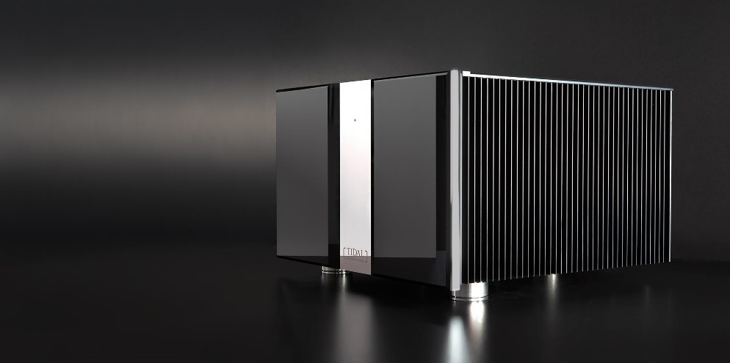

Compared to its "predecessor" Impulse, the birth of Ferios has pushed amplification capabilities to a new limit. It has been upgraded to a 1600VA power supply with true voltage regulation. Therefore, the circuit design of Tidal Ferios Monoblock is considered unique today. According to Tidal Audio, this amplifier is capable of delivering abundant and clean energy, enough to play well with almost any pair of speakers today.

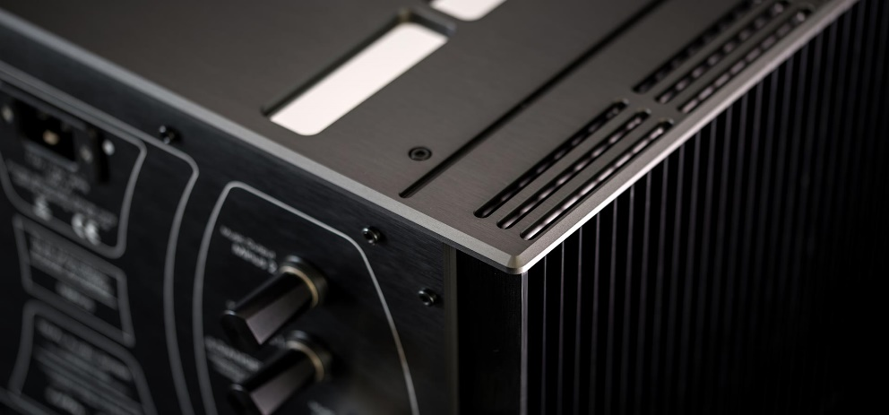

Ferios Monoblock uses a design with 2 amplifier modules running in parallel, it is powered by 2 800VA power transformers. This power supply is equipped with superior voltage regulation capabilities to provide clean and linear power for amplifier circuit operation. This amplifier uses a powerful capacitor system with a stable total capacitance of 410,000 μF with extremely fast response speed. Transistors are carefully selected by hand by the manufacturer to ensure almost absolute reliability.

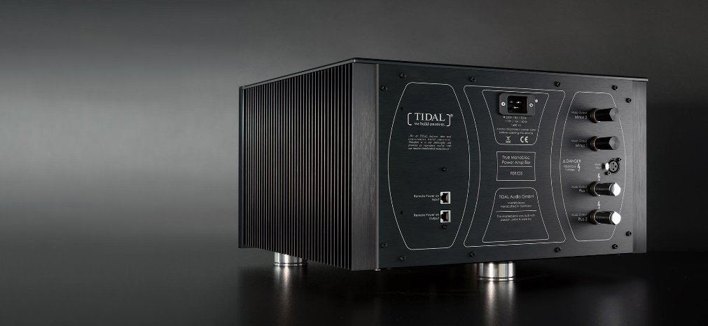

Ferios amplifier is also equipped with Tidal's exclusive APM system with the role of managing and protecting the amplifier circuit, it is arranged completely outside the signal amplifier. The TIDAL APM system is a self-separated and fully automated system for safe voltage management and control: output current relative to output voltage, short-circuit current, DC current compensation, droop voltage and overvoltage.

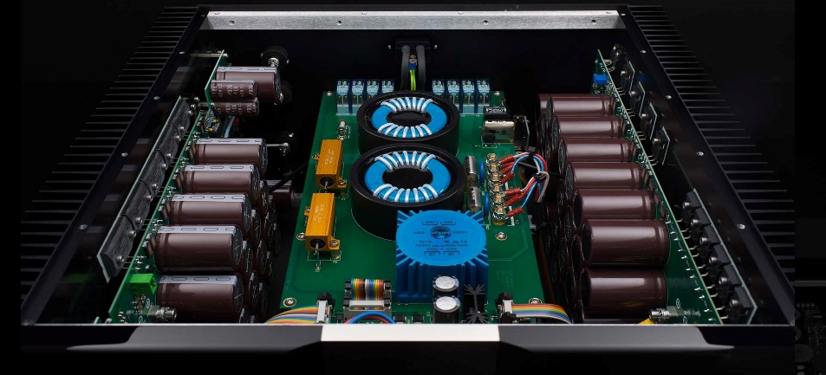

In addition, the manufacturer also offers an option with LPX-monomodule to control the bass range of Tidal reference speakers. This module will make optimal adjustments for low-frequency sound reproduction to help it best suit certain needs and spaces.

Tidal Ferios also has a smart start feature, remote power on/off with the remote of TIDAL pre-amplifiers via RJ45 Ethernet cable connection.